Ian Eggleston

Alone

1. 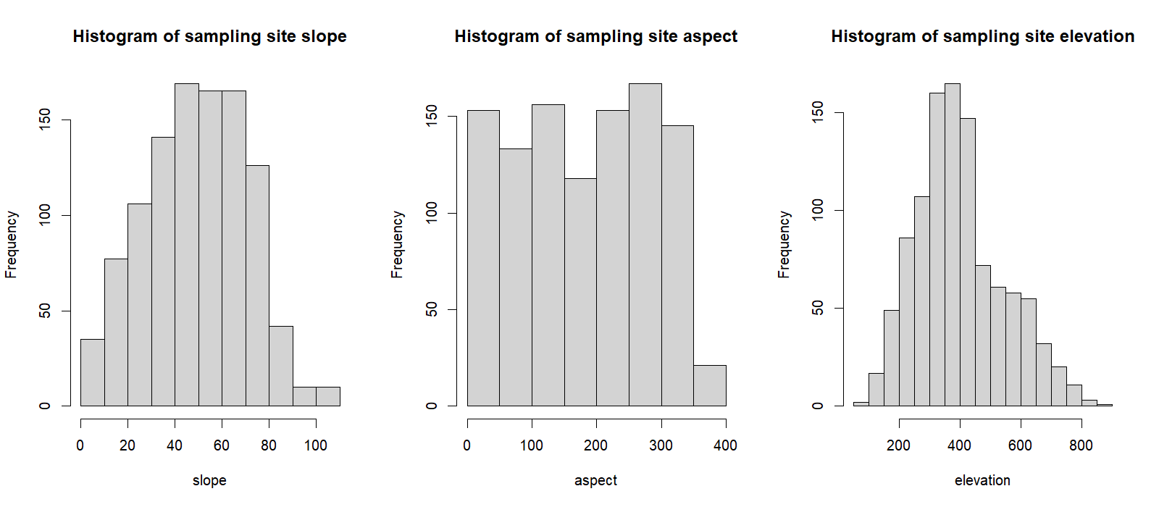
2. The shape of the elevation histogram suggests that you can find a greater amount of birds at an elevation between 300-400 meters. There is a drastic decrease in the amount you can find after 400 meters, but then the trend is steadily decreasing. This suggests most birds prefer an elevation between 200-400 meters but can be found outside of these values. They tend to become less common but are not necessarily uncommon at higher elevations.
3. The unit of slope is frequency at an elevation.
4. The slope histogram shows birds tend to nest in areas that are on a slope. The majority can be found between 30-80, which shows they do not have a preference for flat or steep areas. They can be found in a wide range of habitats, however very few are found at slopes greater than 90. There is an even mix of shallow and steep areas that the birds can be found in, showing great adaptability to a variety of environments.
5. Aspect in this data set references the degrees on a compass the slope faces. This is a numerical value between 0-360.
6. We can see in this dataset that the aspect is not very useful to categorize the bird's habitats. There is an even spread across the data for the aspect values, which shows that the birds do not nest facing specific directions. Although it is not useful to categorize birds, this information can be useful to understand how birds nest.
7. 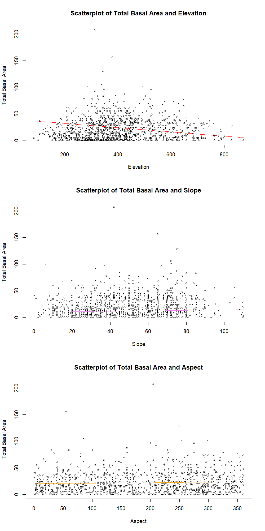
8. There was a slight trend you could detect in most of these scatterplots. Most of these were not linear and a better function could have been used to plot their trends. The first plot shows elevation and total basal area had a negative relationship. At higher elevation the birds were found in areas that had low total basal areas or low tree coverage. The sparse tree coverage at higher elevations could explain this relationship.

Slope had a slightly positive relationship with total basal area, where there was higher tree coverage at slopes around 30-70.Aspect had the least difference across the data points so it was fit with a line that had a slope of 0.01 to represent how little it changed. This is consistent with the histogram data showing how little the aspect affects bird nesting habits.